**Nuvoton Online Firmware Update Tutorial Series - I2C Interface Edition**

In this tutorial, we will use the **NuMaker-NUC1262SE** development board as our test device. Additionally, we need to prepare the **Nu-Link2-Pro**, which is Nuvoton’s all-in-one programming tool. Now, let’s go step by step to implement the **I2C ISP** functionality!  
  
  
**Step 1:** After powering on the **Nu-Link2-Pro**, you will see a disk named **NuMicro MCU**. Open the **NU_CFG.TXT** file inside and modify the value after **BRIDGE-MODE** to **2**. This switches the device to **ISP-LDROM** mode and sets the I2C speed. After saving the file, power cycle the device again.  
  
  
**Step 2:** Next, prepare the **I2C ISP** for the **NUC1261**. The source code can be found at the following link:  
<https://github.com/OpenNuvoton/NUC1261BSP/tree/master/SampleCode/ISP/ISP_I2C>**Step 2**After compiling the project, proceed with programming the firmware. Use the **ICP Programming Tool** to flash the compiled file into **LDROM** and configure the settings to boot from **LDROM**.  
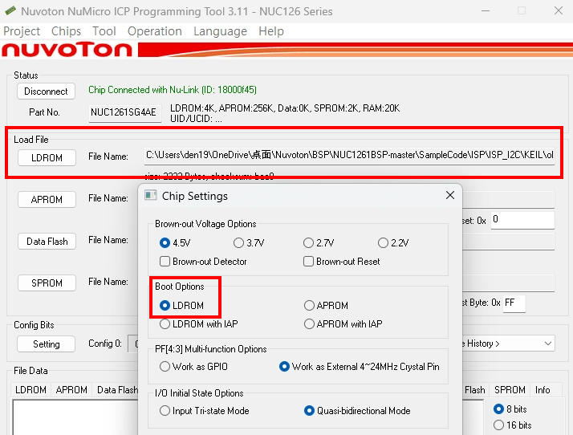  
  
  
**Step 4:**For the hardware setup, connect the **I2C interface** of the **Nu-Link2-Pro Bridge Connector** to the **development board** as follows:

* **Pin 31 (SCL)** → Connect to the SCL pin of the NuMaker-NUC1262SE
* **Pin 32 (SDA)** → Connect to the SDA pin of the NuMaker-NUC1262SE

Once the wiring is complete, you are ready to proceed with the I2C ISP process.

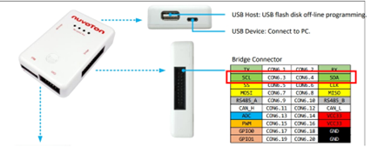  
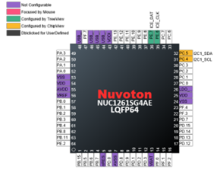  
  
**Step 5:**Next, open the **ISP Tool** and follow these steps:

1. Select the **I2C interface** in the tool.
2. Click the **Connect** button.
3. Press the **Reset** button on the **NuMaker-NUC1262SE MCU** to boot from **LDROM**.
4. Once the connection is successfully established, load a simple code into **APROM**.
5. Click **Program** to start flashing the firmware.

At this point, the I2C ISP process should be successfully executed.

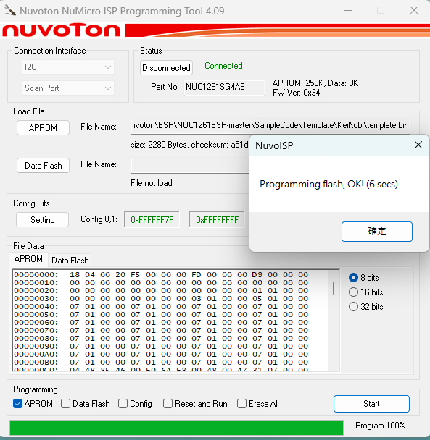  
  
**Step 6:** Finally, reopen the **ICP Programming Tool** and follow these steps:

1. Read the data from the **NUC1262**.
2. Compare the **APROM** code with the original file.
3. Verify if the flashing process was successful.

If the data matches, the **I2C ISP update** has been completed successfully!

